FIGURE 4B

FIGURE 4C

FIGURE 4D

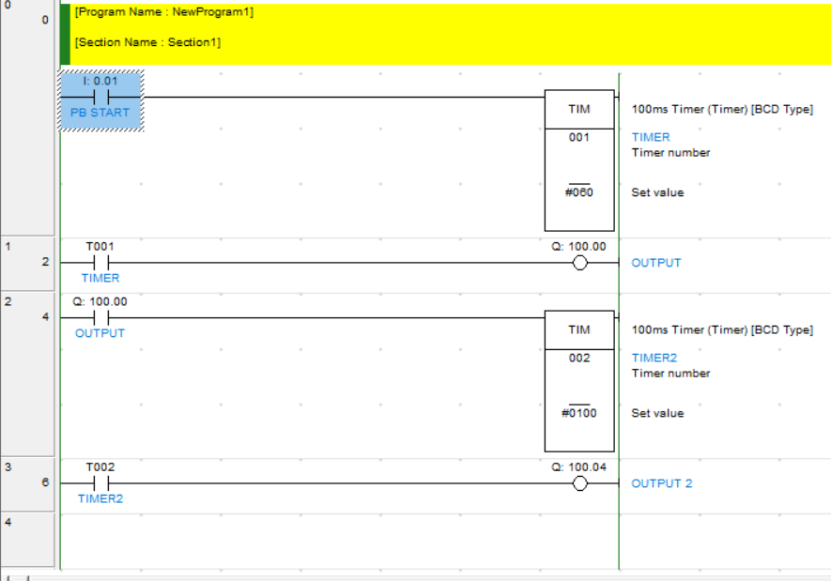

FIGURE 4E

